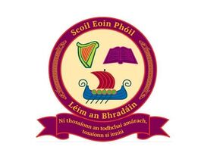
Scoil Eoin Phóil
Green Lane, Leixlip, Co. Kildare
Roll No: 19684O
Telephone: 01-6243130
Email: office@scoileoinphoilleixlip.ie
Website: www.scoileoinphoilleixlip.com

Newsletter January 14th 2022

Dear Parent(s) / Guardian(s),

A warm welcome back to all our families of Scoil Eoin Phoil as we look ahead to bright 2022!
Catholic Schools Week: As the boys and girls returned on Jan 6th, all classes celebrated the Feast of the Epiphany online via the church website. Catholic Schools Week will be taking place the week beginning Jan 24th. The theme for Catholic Schools Week 2022 is ‘Catholic Schools: Living Life to the Full’. All classrooms will participate in a week of celebration, reflecting on their contribution to the common good of our community.
Class Calendars: Just a note to say that each class still has some class calendars remaining should any family still wish to purchase. Please contact the office if you are interest.
Primary Language Curriculum: As part of the Department of Education and Skills’ implementation of the Integrated New Primary Language Curriculum, there will be a half day of in-school training for the teaching staff on January 28th. School will be closing at 12.30pm. An email will be sent in relation to staggered collection times. We will also send a reminder text closer to the date.
Covid – 19: As I am sure you are all aware, new guidelines regarding self-isolation has come into effect today. Any correspondence which we receive from the DES that will help guide parents and provide clarity to various scenarios will be forwarded onto parents. Thank you once again to all families for your continued support. It was been a turbulent start to the new term with many cases within our school community but we are looking forward as always. I would like to thank all our staff members who have been excellent in ensuring the very best level of education we can provide is still being upheld and maintained throughout.

Kind regards,
Seán O Boyle

